Friday 8th October 2020

Dear Parents and Carers of 4 Pankhurst,

Next week, I will be teaching children using Microsoft teams. All children must log in to Microsoft teams in order to access the learning. To do this you need to follow the below instructions:

- Google Microsoft teams and click on the first option.

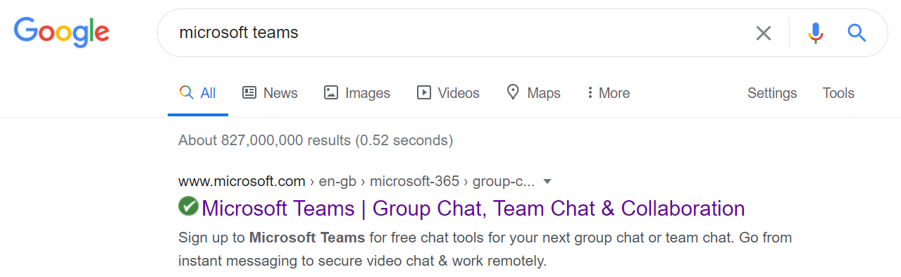

- On the home page, click log in.

- To sign in, type 16 then use the first letter of your child’s name and your surname. I have shown mine as an example, so16, the first letter of my name - E and then my surname uka followed by @rpa.bfet.uk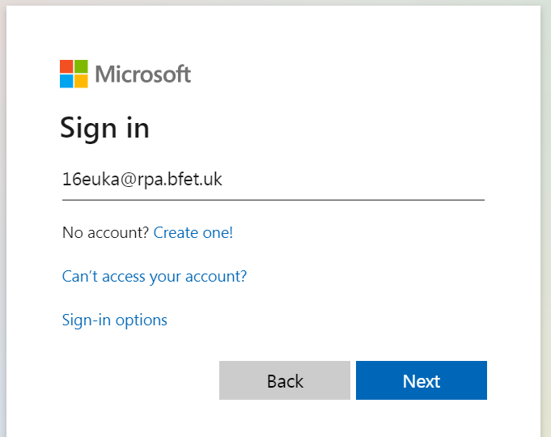

- You will be asked to enter the password which is: Rushbrook1

Once you have done that, you will be raring to go!

There are certain times throughout the day that the children will have to be logged into teams, this is because I will be teaching them live via teams. I will be video calling, and then the children will have a short lesson with me before going to do some of the work in the packs that have been sent home.

PLEASE MAKE SURE YOUR CHILD IS SOMEWHERE QUIET, if they are not then they will disturb the rest of the classes learning.

The timetable for the week will be as follows. Please note the times in red. These are the times of the live lesson, and when the child must be logged into teams for the call.

Monday | Tuesday | Wednesday | Thursday | Friday
Maths  9:30 on teams for start of lesson.  9:45-10:15(approx.) independent task. Mrs Uka available on teams to instant message if child is stuck.  10:15 log back into teams for plenary. | Maths  9:30 on teams for start of lesson.  9:45-10:15(approx.) independent task. Mrs Uka available on teams to instant message if child is stuck.  10:15 log back into teams for plenary. | Maths  9:30 on teams for start of lesson.  9:45-10:15(approx.) independent task. Mrs Uka available on teams to instant message if child is stuck.  10:15 log back into teams for plenary. | Maths  9:30 on teams for start of lesson.  9:45-10:15(approx.) independent task. Mrs Uka available on teams to instant message if child is stuck.  10:15 log back into teams for plenary. | Maths  9:30 on teams for start of lesson.  9:45-10:15(approx.) independent task. Mrs Uka available on teams to instant message if child is stuck.  10:15 log back into teams for plenary.
BREAK | BREAK | BREAK | BREAK | BREAK
English  11:00 on teams for start of lesson.  11:15-11:45(approx.)  independent task. Mrs Uka available on teams to instant message if child is stuck.  11:45 log back into teams for plenary | English  11:00 on teams for start of lesson.  11:15-11:45(approx.)  independent task. Mrs Uka available on teams to instant message if child is stuck.  11:45 log back into teams for plenary | English  11:00 on teams for start of lesson.  11:15-11:45(approx.)  independent task. Mrs Uka available on teams to instant message if child is stuck.  11:45 log back into teams for plenary | English  11:00 on teams for start of lesson.  11:15-11:45(approx.)  independent task. Mrs Uka available on teams to instant message if child is stuck.  11:45 log back into teams for plenary | English  11:00 on teams for start of lesson.  11:15-11:45(approx.)  independent task. Mrs Uka available on teams to instant message if child is stuck.  11:45 log back into teams for plenary
LUNCH | LUNCH | LUNCH | LUNCH | LUNCH
Science/ Reading  Mrs Uka available over teams to instant message. | History/Reading  Mrs Uka available over teams to instant message. | Art/Reading  Mrs Uka available over teams to instant message | Black History/Reading  Mrs Uka available over teams to instant message | PE/Reading  For the PE lesson choose to do something active! You could use a Joe Wicks workout,or choose a GoNoodle activity on Youtube!  Mrs Uka available over teams to instant message
2:45 log back in for goodbye and story time! | 2:45 log back in for goodbye and story time! | 2:45 log back in for goodbye and story time! | 2:45 log back in for goodbye and story time! | 2:45 log back in for goodbye and story time!

Please make sure your child brings the work pack back into school on the 20th of October. I will be taking a register of the children who access teams every day. Do contact us if you have any issues.

I look forward to seeing your child on teams on Monday morning.

Thank you,

Mrs Uka

