Saturday 24th October 2020

Dear Parents and Carers of Nursery

We have been notified that a member of your child’s class and/or set bubble has tested positive for COVID-19. We have followed the national guidance and have identified that your child has been in close contact with the affected person. As a precaution, Greater Manchester Contact Tracing Hub and Public Health England (PHE) have said your child needs to isolate at home for 14 days from last contact. Isolation ends on Wednesday 4th November. Your child should return to school on Thursday 5th November 2020.
Other members of your household can continue normal activities provided your child does not develop symptoms within the 14 day self-isolation period. Please see the link to the PHE Staying at Home Guidance. All siblings are still expected to come to school.
https://www.gov.uk/government/publications/covid-19-stay-at-home-guidance/stay-at-home-guidance-for-households-with-possible-coronavirus-covid-19-infection
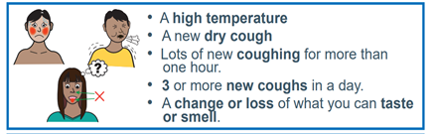
Your child does not need a test unless they develop symptoms. A negative test does not mean that your child can return to school earlier than 14 days.
If your child does develop symptoms, you can seek advice from NHS 111 at https://www.nhs.uk/conditions/coronavirus-covid-19/check-if-you-have-coronavirus-symptoms/or by phoning 111. Please also call the school on 0161 223 5955.
As the isolation period is across the school holiday, we will not be providing home learning for this period as we want the children to rest as usual. We will provide learning for the 3 days following the half term break. If you are eligible for Free School Meals, we will arrange a voucher for whilst your child is absent from school. We will provide this voucher with the home learning pack.

As a school, we are following the government guidance to ensure the safety of our pupils, their families and our staff. Our social distancing measures, cleaning and hygiene arrangements are in place throughout the day. We are carrying out extra cleaning of the classroom ready for your child’s return on the 5th November.
There is further information about Coronavirus on our school website and the leaflet overleaf

As ever, thank you for your support during this difficult and challenging time.

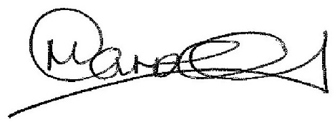

Mr Carroll
Principal

