Tuesday 3rd November 2020

Staffing Update

Dear Parents and Carers of 3 Turing

I wanted to update you on a temporary staffing change in 3 Turing that will be taking place from Monday 9th November 2020.

Mr Heywood is about to become a Dad and so will be taking a period of paternity leave so that he can spend some time with his new family. This is wonderful news for Mr Heywood and his partner, and we fully support him in wanting to have this precious time with his new baby when he or she arrives next week.

Whilst Mr Heywood is away from school, Mr Levi will teach the children alongside Miss Parkin and Miss Davies who are the regular learning assistants in the class. The children have already met Mr Levi previously so this should be a familiar face to them.

Mr Heywood will make sure that he discusses all children with Mr Levi before their return on Monday to ensure a smooth transition for the children.

Mr Heywood is due to return on Monday 11th January 2021 and we wish him all the best.

Should you have any questions in the meantime, please do not hesitate in contacting Miss Wallace, Assistant Principal for Years 3 and 4, or myself.

Thank you in advance for your support.

Kind Regards

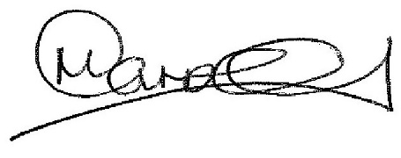

Mr Carroll

