Wednesday 25th November 2020

Dear Parents and Carers of 4 Turing

We have been notified that a member of your child’s class and/or set bubble has tested positive for COVID-19. We have followed the national guidance and have identified that your child has been in close contact with the affected person. As a precaution, Greater Manchester Contact Tracing Hub and Public Health England (PHE) have said your child needs to isolate at home for 14 days. Isolation ends on Tuesday 15th December. Your child should return to school on Wednesday 16th December.
Other members of your household can continue normal activities provided your child does not develop symptoms within the 14 day self-isolation period. Please see the link to the PHE Staying at Home Guidance. All siblings are still expected to come to school. If you need help to get their brothers and/or sisters into school, please let us know.
https://www.gov.uk/government/publications/covid-19-stay-at-home-guidance/stay-at-home-guidance-for-households-with-possible-coronavirus-covid-19-infection
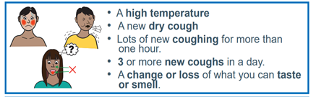
Your child does not need a test unless they develop symptoms. A negative test does not mean that your child can return to school earlier than 14 days.
If your child does develop symptoms, you can seek advice from NHS 111 at https://www.nhs.uk/conditions/coronavirus-covid-19/check-if-you-have-coronavirus-symptoms/or by phoning 111. Please also call the school on 0161 223 5955.
School will provide your child with paper-based learning and we will also contact you about remote learning. If you do not receive this, please contact the main school office. If you are eligible for Free School Meals we will arrange for food vouchers to be sent to you whilst your child is absent, please also contact the main school office.

As a school, we are following the government guidance to ensure the safety of our pupils, their families and our staff. Our social distancing measures, cleaning and hygiene arrangements are in place throughout the day. We are carrying out extra cleaning of the classroom ready for your child’s return on Wednesday 16th December 2020.
There is further information about Coronavirus on our school website and the leaflet overleaf

As ever, thank you for your support during this difficult and challenging time.

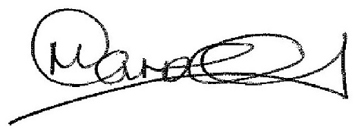

Mr Carroll
Principal

