Tuesday 1st December 2020

Dear Parents and Carers,

This week and next, I will be teaching children using Microsoft teams (Starting 9.30AM on Thursday 3rd December).

All children must log in to Microsoft teams to access the learning. It is the same process as last time, so hopefully you and your child are familiar with this.

To log in to Microsoft Teams, please follow the instructions below:

- Google Microsoft teams and click on the first option.

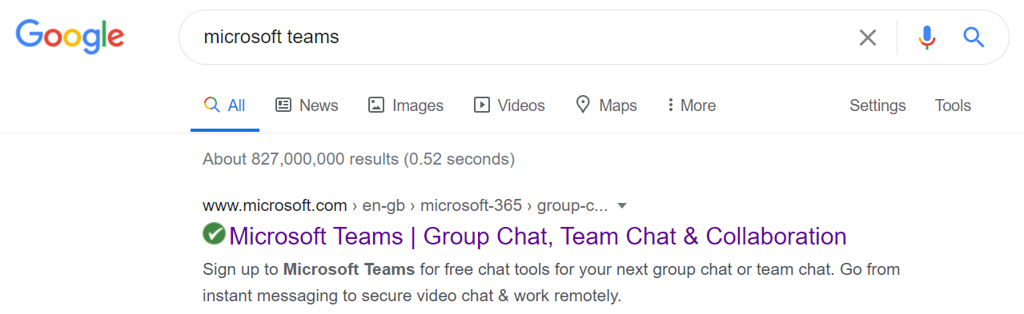

- On the home page, click sign in.

- To sign in, type 16 then use the first letter of your child’s name and your surname. I have shown mine as an example, so 17, the first letter of my name - M and then my surname Foreman followed by @rpa.bfet.uk

- You will be asked to enter the password which is: Rushbrook1

Once you have done that, you will be raring to go!

There are certain times throughout the day that the children will have to be logged into teams, this is because I will be teaching them live. I will be video calling, and then the children will have a short lesson with me before going to do some independent activities that I will set.

PLEASE MAKE SURE YOUR CHILD IS SOMEWHERE QUIET, if they are not then they will disturb the rest of the classes learning.

The timetable for the week will be as follows. Please note the times in red. These are the times of the live lesson, and when the child must be logged into teams for the call. Please note the live lessons start on Thursday 3rd December and will end on Friday 11th December. I will be taking a register of the children who access teams every day.
Monday | Tuesday | Wednesday | Thursday | Friday
Maths  9:30 on teams for start of lesson.  9:45-10:15(approx.) independent task. Mr Foreman available on teams to instant message if child is stuck.  10:15 log back into teams for plenary. | Maths  9:30 on teams for start of lesson.  9:45-10:15(approx.) independent task. Mr Foreman available on teams to instant message if child is stuck.  10:15 log back into teams for plenary. | Maths  9:30 on teams for start of lesson.  9:45-10:15(approx.) independent task. Mr Foreman available on teams to instant message if child is stuck.  10:15 log back into teams for plenary. | Maths  9:30 on teams for start of lesson.  9:45-10:15(approx.) independent task. Mr Foreman available on teams to instant message if child is stuck.  10:15 log back into teams for plenary. | Maths  9:30 on teams for start of lesson.  9:45-10:15(approx.) independent task. Mr Foreman available on teams to instant message if child is stuck.  10:15 log back into teams for plenary.
BREAK | BREAK | BREAK | BREAK | BREAK
English  11:00 on teams for start of lesson.  11:15-11:45(approx.)  independent task. Mr Foreman available on teams to instant message if child is stuck.  11:45 log back into teams for plenary | English  11:00 on teams for start of lesson.  11:15-11:45(approx.)  independent task. Mr Foreman available on teams to instant message if child is stuck.  11:45 log back into teams for plenary | English  11:00 on teams for start of lesson.  11:15-11:45(approx.)  independent task. Mr Foreman available on teams to instant message if child is stuck.  11:45 log back into teams for plenary | English  11:00 on teams for start of lesson.  11:15-11:45(approx.)  independent task. Mr Foreman available on teams to instant message if child is stuck.  11:45 log back into teams for plenary | English  11:00 on teams for start of lesson.  11:15-11:45(approx.)  independent task. Mr Foreman available on teams to instant message if child is stuck.  11:45 log back into teams for plenary
LUNCH | LUNCH | LUNCH | LUNCH | LUNCH
Reading  13:00 on teams for start of lesson.  13:15-13:45 (approx..) Mr Foreman available over teams to instant message.  Geography  13:45 on teams for start of lesson.  14:00-14:30(approx.)  independent task. Mr Foreman available on teams to instant message if child is stuck.  14:30 log back in for plenary, story time and goodbye! | Reading  13:00 on teams for start of lesson.  13:15-13:45 (approx..) Mr Foreman available over teams to instant message.  Science  13:45 on teams for start of lesson.  14:00-14:30(approx.)  independent task. Mr Foreman available on teams to instant message if child is stuck.  14:30 log back in for plenary, story time and goodbye! | Reading  13:00 on teams for start of lesson.  13:15-13:45 (approx..) Mr Foreman available over teams to instant message.  Art  13:45 on teams for start of lesson.  14:00-14:30(approx.)  independent task. Mr Foreman available on teams to instant message if child is stuck.  14:30 log back in for plenary, story time and goodbye! | Reading  13:00 on teams for start of lesson.  13:15-13:45 (approx..) Mr Foreman available over teams to instant message.  Computing  13:45on teams for start of lesson.  14:00-14:30(approx.)  independent task. Mr Foreman available on teams to instant message if child is stuck.  14:30 log back in for plenary, story time and goodbye! | Reading  13:00 on teams for start of lesson.  13:15-13:45 (approx..) Mr Foreman available over teams to instant message.  PE  13:45 on teams for start of lesson.  14:00-14:30(approx.)  independent task. Mr Foreman available on teams to instant message if child is stuck.  14:30 log back in for plenary, story time and goodbye!

Please make sure your child brings their pack of work back into school on Monday 14th of December.

I look forward to seeing your child on teams on Thursday morning.

Thank you,

Mr Foreman

