Friday 4th December 2020

Dear Parents and Carers,

From Monday 7th December, I will be calling your children using Microsoft Teams every day to check in with them.

These sessions will include reading with your child and answering any questions they may have about the work provided for them. Please make sure that they have their home pack learning with them.

The timetable is set as this:

9:15 – 9:35 | 9:40 – 10:00 | 10:05 – 10:25 | 10:30 – 10:50 | 11:05 – 11:25 | 11:30 11:50 | 11:50 – 12:10 | 1:00 – 1:15 | 1:20 – 1:35 | 1:40 – 1:55 | 2:00 – 2:15
Hajra | Yasmeen | Amalia | Salman | Marwa | Lucas | Leon | Taim | Moosa | Shelby | Alleigha

All children must log in to Microsoft teams to access the call. Instructions for using Teams is on the next page.

I look forward to seeing your child on teams on Monday morning.

Thank you,

Miss McLellan

To log in to Microsoft Teams, please follow the instructions below:

- Google Microsoft teams and click on the first option.

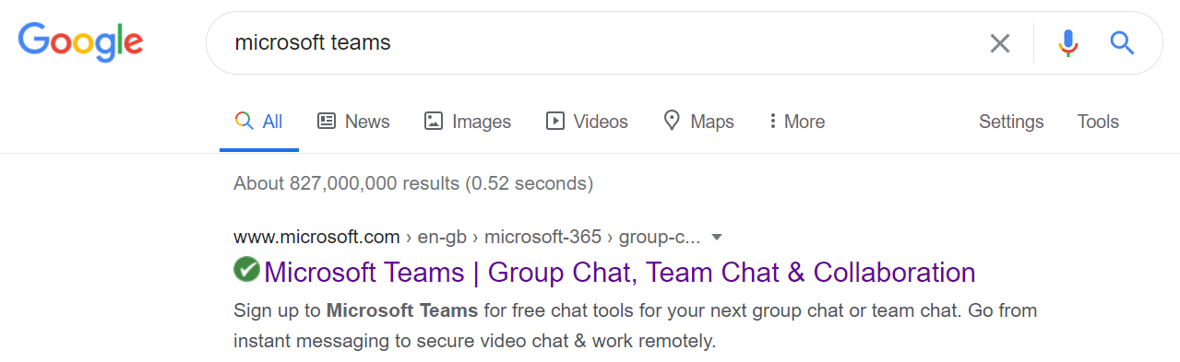

- On the home page, click sign in.
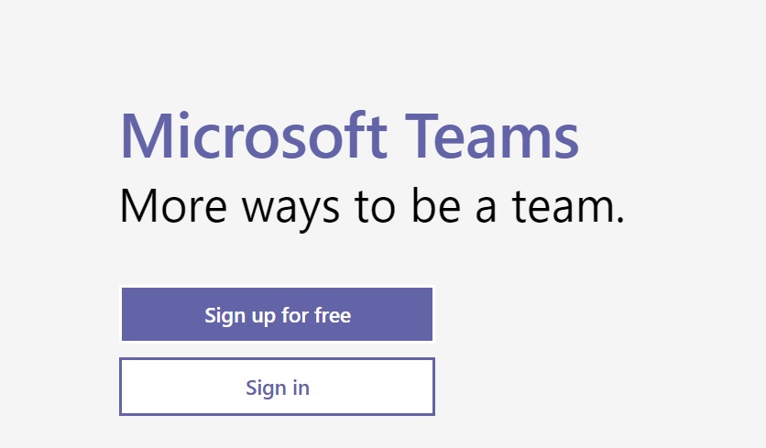

- To sign in, type 16 then use the first letter of your child’s name and your surname. I have shown mine as an example, so 17, the first letter of my name - M and then my surname Foreman followed by @rpa.bfet.uk

- You will be asked to enter the password which is: Rushbrook1

PLEASE MAKE SURE YOUR CHILD IS SOMEWHERE QUIET, so they can concentrate.

