Wednesday 6th January 2020

Dear Parents and Carers of Year 3

During the lockdown period, Mr Armaan and Mr Heywood will be teaching children using Microsoft teams (Starting 9.30AM on Thursday 7th January 2020).

All children must log in to Microsoft teams to access the learning. It is the same process as last time, so hopefully you and your child are familiar with this.

To log in to Microsoft Teams, please follow the instructions below:

- Google Microsoft teams and click on the first option.

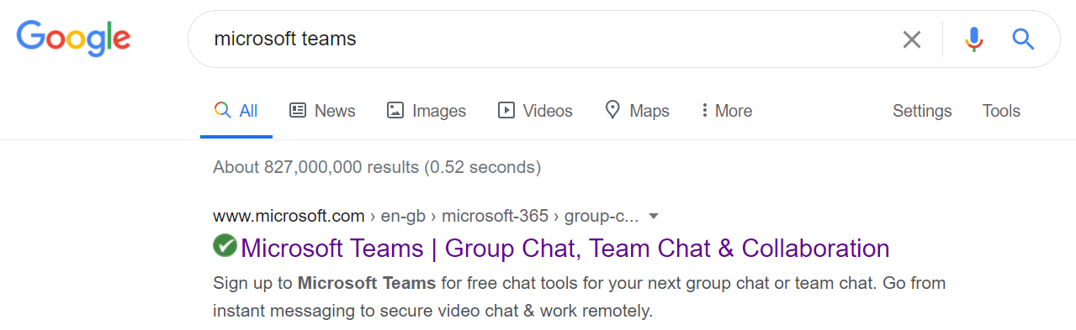

- On the home page, click sign in.

- To sign in, type 17 then use the first letter of your child’s name and your surname. I have shown one as an example, so 17, the first letter of my name – M and then my surname Armaan followed by @rpa.bfet.uk
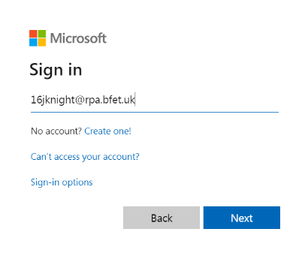

- You will be asked to enter the password which is: Rushbrook1

Once you have done that, you will be raring to go!

There are certain times throughout the day that the children will have to be logged into teams, this is because I will be teaching them live. I will be video calling, and then the children will have a short lesson with me before going to do some independent activities that I will set.

PLEASE MAKE SURE YOUR CHILD IS SOMEWHERE QUIET, if they are not then they will disturb the rest of the classes learning. It has helped the children in the past if they wear their school jumper when online. This helps them to link the learning with school.

The timetable for each week will be as follows. Please note the times in red. These are the times of the live lesson, and when the child must be logged into teams for the call. Please note the live lessons start on Thursday 7th January 2020. I will be taking a register of the children who access teams every day. Some of the afternoon subjects may change but the adults will inform the children of this.

Monday | Tuesday | Wednesday | Thursday | Friday
Maths  9:30 on teams for start of lesson.  9:45-10:15(approx.) independent task. My teacher will be available on teams to instant message if child is stuck.  10:15 log back into teams for plenary. | Maths  9:30 on teams for start of lesson.  9:45-10:15(approx.) independent task. My teacher will be available on teams to instant message if child is stuck.  10:15 log back into teams for plenary. | Maths  9:30 on teams for start of lesson.  9:45-10:15(approx.) independent task. My teacher will be available on teams to instant message if child is stuck.  10:15 log back into teams for plenary. | Maths  9:30 on teams for start of lesson.  9:45-10:15(approx.) independent task. My teacher will be available on teams to instant message if child is stuck.  10:15 log back into teams for plenary. | Maths  9:30 on teams for start of lesson.  9:45-10:15(approx.) independent task. My teacher will be available on teams to instant message if child is stuck.  10:15 log back into teams for plenary.
BREAK | BREAK | BREAK | BREAK | BREAK
English  11:00 on teams for start of lesson.  11:15-11:45(approx.)  independent task. My teacher will be available on teams to instant message if child is stuck.  11:45 log back into teams for plenary | English  11:00 on teams for start of lesson.  11:15-11:45(approx.)  independent task. My teacher will be available on teams to instant message if child is stuck.  11:45 log back into teams for plenary | English  11:00 on teams for start of lesson.  11:15-11:45(approx.)  independent task. My teacher will be available on teams to instant message if child is stuck.  11:45 log back into teams for plenary | English  11:00 on teams for start of lesson.  11:15-11:45(approx.)  independent task. My teacher will be available on teams to instant message if child is stuck.  11:45 log back into teams for plenary | English  11:00 on teams for start of lesson.  11:15-11:45(approx.)  independent task. My teacher will be available on teams to instant message if child is stuck.  11:45 log back into teams for plenary
LUNCH | LUNCH | LUNCH | LUNCH | LUNCH
Reading  13:00 on teams for start of lesson.  13:15-13:45 (approx.) My teacher will be available over teams to instant message.  Geography or History  13:45 on teams for start of lesson.  13:45-14:15(approx.)  independent task My teacher will be available on teams to instant message if child is stuck.  14:30 log back in for plenary, story time and goodbye! | Reading  13:00 on teams for start of lesson.  13:15-13:45 (approx.) My teacher will be available over teams to instant message.  Science  13:45 on teams for start of lesson.  13:45-14:15(approx.)  independent task. My teacher will be available on teams to instant message if child is stuck.  14:30 log back in for plenary, story time and goodbye! | Reading  13:00 on teams for start of lesson.  13:15-13:45 (approx.) My teacher will be available over teams to instant message.  Computing  13:45 on teams for start of lesson.  13:45-14:15(approx.)  independent task. My teacher will be available on teams to instant message if child is stuck.  14:30 log back in for plenary, story time and goodbye! | Reading  13:00 on teams for start of lesson.  13:15-13:45 (approx.) My teacher will be available over teams to instant message.  Art  13:45 on teams for start of lesson.  13:45-14:15(approx.)  independent task. My teacher will be available on teams to instant message if child is stuck.  14:30 log back in for plenary, story time and goodbye! | No Live Lessons as staff will be planning for next week’s lessons

Please make sure your child brings their packs of work back into school upon their return.

We look forward to seeing your child on teams on Thursday morning.

Thank you,

Mr Armaan and Mr Heywood

