Tuesday 16th March 2021

Dear Parents and Carers of Year 6 Bubble

We have been notified that a member of your child’s bubble has tested positive for COVID-19. We have followed the national guidance and have identified that your child has been in close contact with the affected person. As a precaution, Greater Manchester Contact Tracing Hub and Public Health England (PHE) have said your child needs to isolate at home for 10 days. Isolation ends on Thursday March 25th. Your child should return to school Friday March 26th 2021.
Other members of your household can continue normal activities provided your child does not develop symptoms within the 10 day self-isolation period. Please see the link to the PHE Staying at Home Guidance. All siblings are still expected to come to school. If you need help to get their brothers and/or sisters into school, please let us know.
https://www.gov.uk/government/publications/covid-19-stay-at-home-guidance/stay-at-home-guidance-for-households-with-possible-coronavirus-covid-19-infection
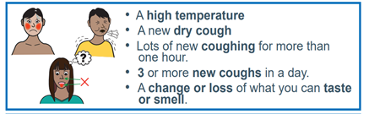
Your child does not need a test unless they develop symptoms. A negative test does not mean that your child can return to school earlier than 10 days.
If your child does develop symptoms, you can seek advice from NHS 111 at https://www.nhs.uk/conditions/coronavirus-covid-19/check-if-you-have-coronavirus-symptoms/or by phoning 111. Please also call the school on 0161 223 5955.
The class will now move to remote learning; this will begin on Thursday 18th March. We will be in contact with you to identify if you require a laptop in order to access the learning. If you are in receipt of Free School Meals, you will be provided with vouchers whilst your child is isolating.

As a school, we are following the government guidance to ensure the safety of our pupils, their families and our staff. Our social distancing measures, cleaning and hygiene arrangements are in place throughout the day. We are carrying out extra cleaning of the classroom ready for your child’s return on Friday 26th March 2021.
There is further information about Coronavirus on our school website and the leaflet overleaf

As ever, thank you for your support during this difficult and challenging time.

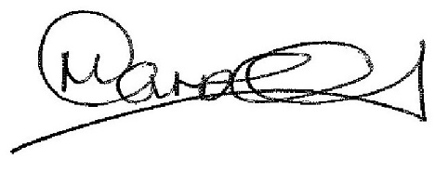

Mr Carroll
Principal

